A facilitator of mine referred me to the site where I saw this data. I became very interested in this data when I saw the high rate of layoff of staff in the tech industry. The most shocking part was that it was a recent data (2020–2023). I always had the belief that “no matter what, developers can't be laid off ", but after scanning through this data my ideology changed, and I am willing to know the cause of the high rate of staff layoff.

***Data Set Details***

This data was sourced from kaggle.com, https://www.kaggle.com/datasets/swaptr/layoffs-2022. It is a CSV file. Kaggle has sourced this data from different tech industries. I am about to start work on the 23/01/2023 version. Company name (This is the name of the company that has laid off some of its staff), Location (This is the city where the company which laid off her staff is located.); Industry (This is like a division/classification of the category of the firm that staff were laid off), Total laid off (This is the total number of staff that was layoff by the company.), Percentage laid off (This is the percentage of laid off staff to the total population of staff in the company), Date (This is the day of layoff), Stage ( is the level of the fund raised by the company: the meaning of series A-D was found on this platform), Country –(this the country where the company are situated), Fund raised( this is the amount that the company has submitted)

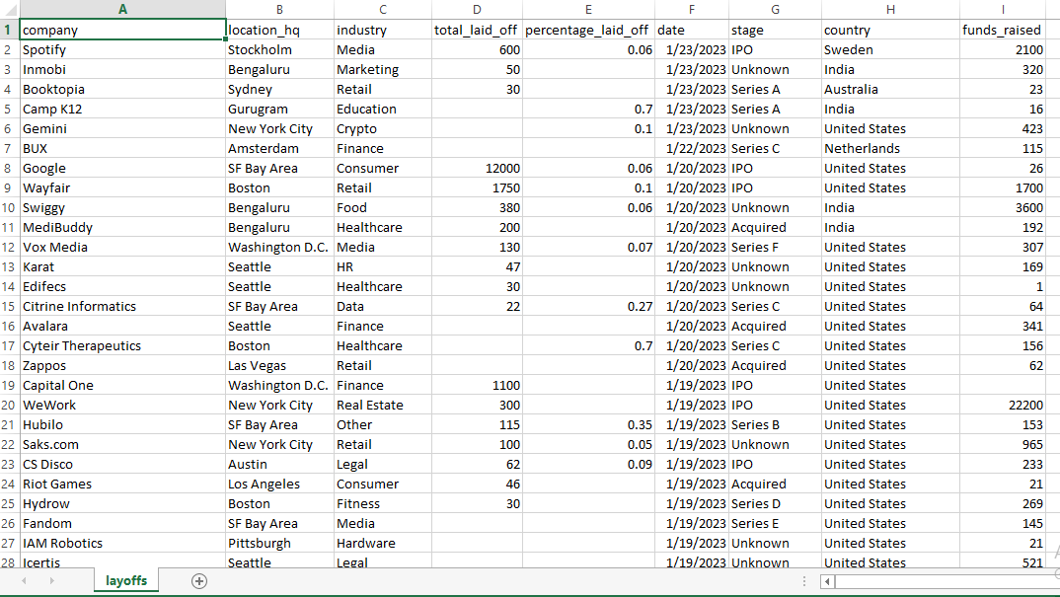

Fig1: Data before Cleaning

***Data cleaning tip***

It is essential to clean the data before analyzing it because it may contain unwanted entries.

I started data cleaning by changing the data type of the percentage-layoff column from decimal to percentage.

To calculate the "total number of staff before the layoff occurred," use this formula " =IFERROR (D3/E3,"-") ". To estimate the number of staff before the layoff occurs.

I inserted another column to calculate the "total number of staff after the layoff" using the formula "=IFERROR (J3-D3,"-")" to get an estimate of how many employees were still employed.

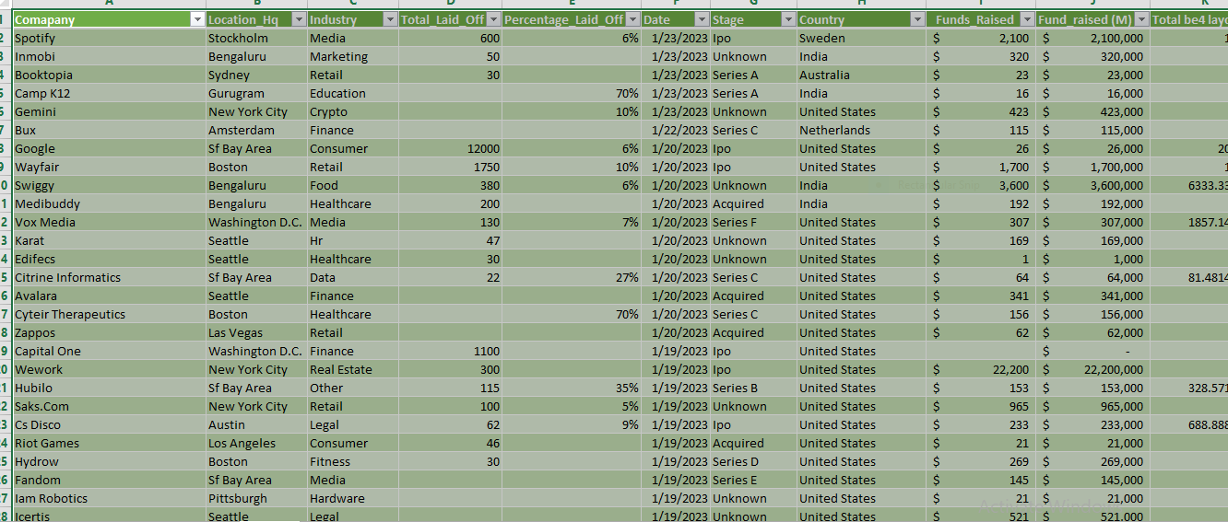

Fig1: Data with table 1 extracted the year and month from the date column.

I changed the data type of funds raised from general to currency.

Finally, I removed all duplicated values from the dataset.

I turned the dataset into a table format, which was then summarized into a pivot table.

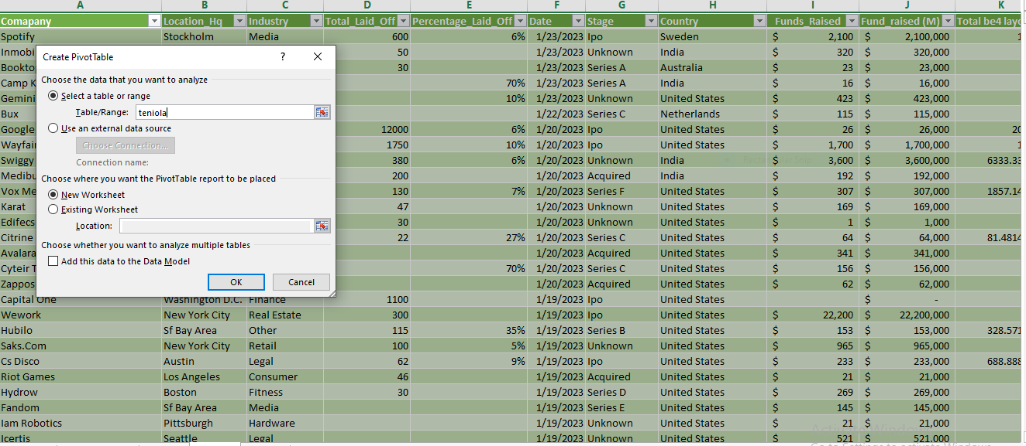

Fig 2: the creation of pivot table Data Analysis

I analyzed the dataset after summarizing my table to a pivot table, and I was able to provide answers to some of the following questions:

· The total layoff between the years 2020–2023

· The layoff by month

· The company with the highest fundraised

· The stage with the highest fundraised and layoff

· The industry with the highest fundraiser

· Layoff per month

The total layoff between 2020–2023:

This was represented as "Layoff by year" on the dashboard, and the pivot table shows the following: I inserted the year column into the row tab and inserted the "total laid off" column into the value tab (this sums up the values automatically). 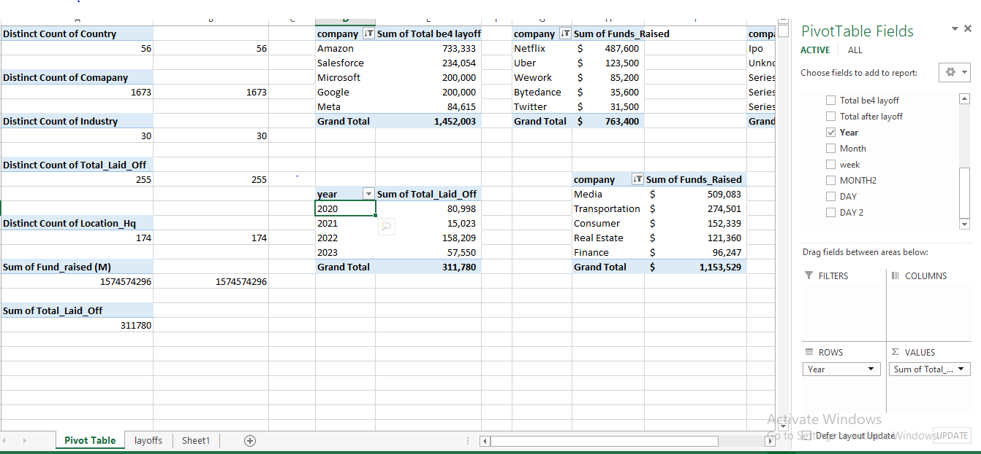

Fig 3: the creation of pivot by year

The highest layoff was experienced in 2022, and the least layoff was in 2021. This was visualized by selecting a doughnut chart from the "Insert tab: Recommended chart ribbon." I selected a pie chart because the category was between 2 and 4 values.

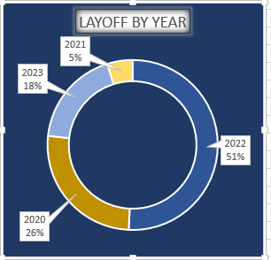

Fig 4: Representation by Layoff by year

***The companies that laid off their staff (by the company):***

The top 5 companies with the most layoffs between 2020 and 2023 were Microsoft, Salesforce, Meta, Google and Amazon. Microsoft had 10,000 layoffs, or about 3.2% of all layoffs, while Salesforce, Meta, Google and Amazon laid off 10,090, 11,000, 12,000 and 18,150staffs respectively.

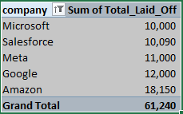

Fig 5: Pivot table of top 5 company

This was visualized by selecting a bar chart from the "Insert tab: Recommended chart ribbon."

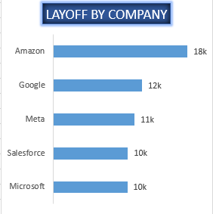

Fig 6: Representation of layoff by company

***The company with the highest fundraising:***

The top 5 most funded companies between 2020 and 2023 were Netflix, Uber, WeWork, Bytedance, and Twitter. Netflix got approximately $490,600,000 in funding, about 63% of the funds raised from 2020 to 2023, while Amazon, which had the highest layoffs, was not part of five most funded company within that period.

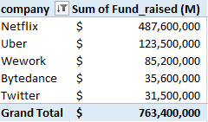

Fig 7: Pivot table of Top 5 most funded comapany.

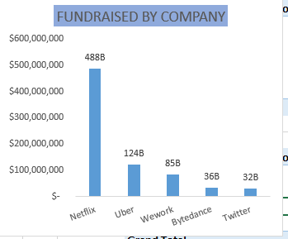

Fig 8: Representation of fund raised by company

The stage with the highest fundraise and layoff:

The companies at the IPO funding stage laid off the most and also got the highest fundraised. They laid off approximately 150,000 employees between 2020 and 2023 and were able to secure funding of approximately $962,177 billion, or about 72% of the total funds raised within that period.

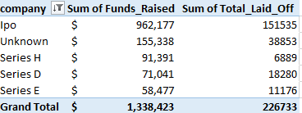

Fig 9: Fundraised and total laid off by stages

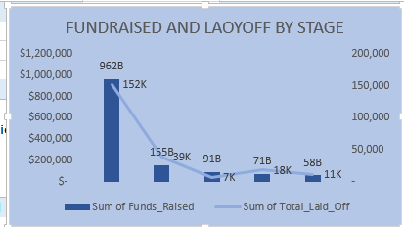

Fig 10: Representation of Fundraised and Layoff by stage

***DATA VISUALIZATION***

It was advice to always draw a sketch of your intended dashboard template before beginning to analyze with the pivot table, the design and formatting can be done on Microsoft Excel.

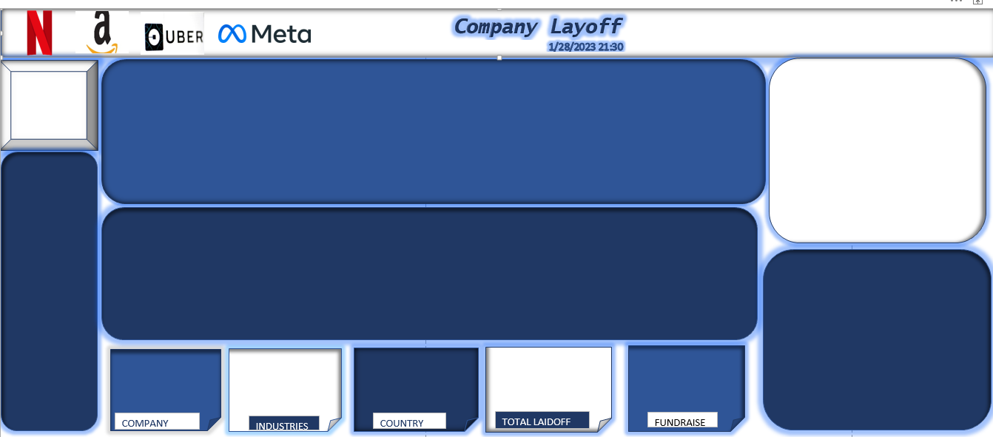

Fig 11: A Sketch of The Dashboard for my Dashboard, I do my sketch on a piece of paper.

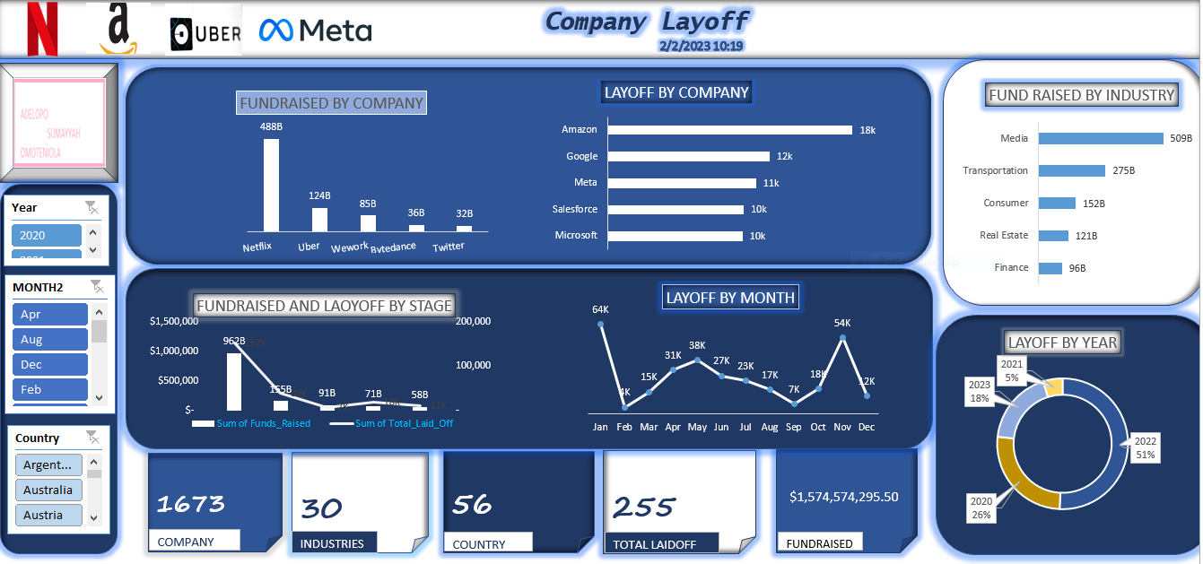

Fig 12: Final Dashboard

This is my first time working on a data analysis project, comments, and recommendations from experts would be appreciated, thank you.